Project Title
Digital Patient Record Management System for Healthcare Facilities in South Sudan
Use Case Diagram
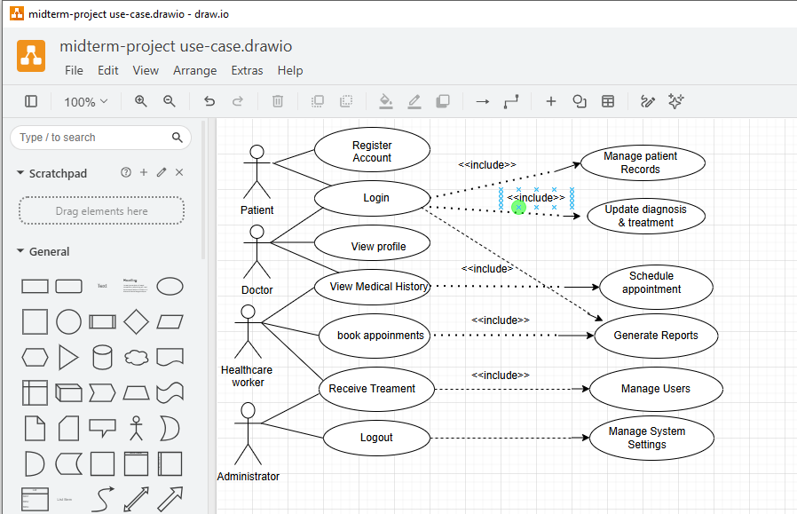
The Use Case Diagram illustrates how different users interact with the Digital Patient Record Management System. The main actors are the Patient, Doctor, Healthcare Worker, and Administrator. Patients can register an account, log in, view their profile, and book appointments. Doctors can access patient medical history and update diagnosis and treatment information. Healthcare workers manage patient records, schedule appointments, and generate reports. Administrators manage users and configure system settings to ensure the smooth operation of the system.
Sequence Diagram (Login Scenario)
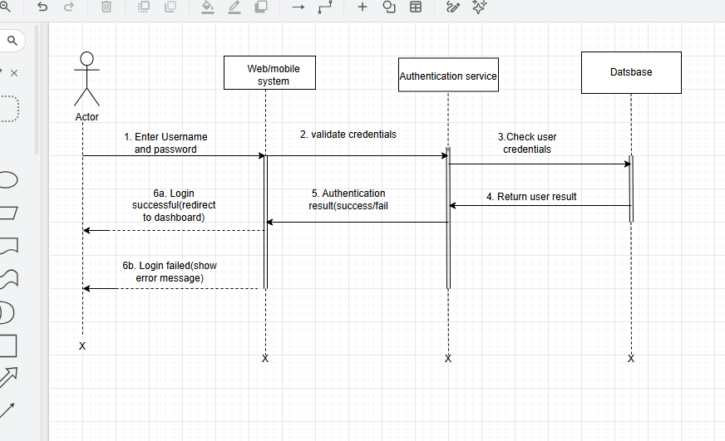
The Sequence Diagram illustrates the login process of the system. The process begins when the user enters a username and password through the web or mobile application. The system forwards the login request to the authentication service, which verifies the credentials stored in the database. If the login details are correct, the user is redirected to the dashboard. If the credentials are invalid, the system displays an error message and denies access.

Entity Relationship Diagram (ERD)
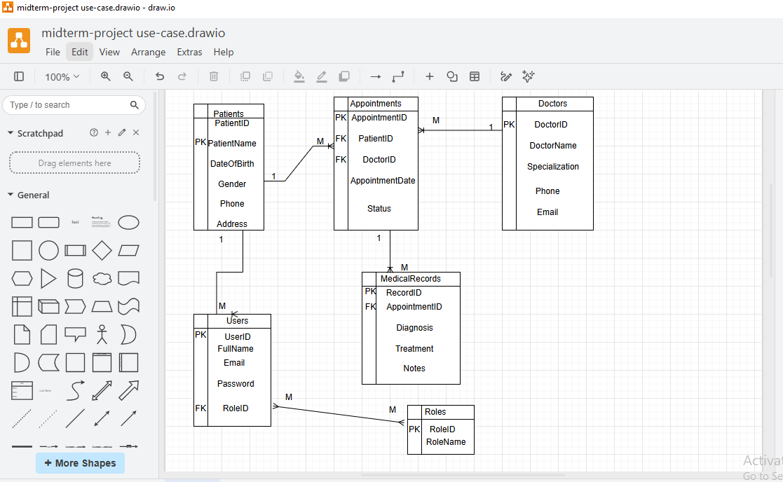
The Entity Relationship Diagram illustrates the relationships between the main entities in the system.
The Patients table stores patient personal information, while the Doctors table stores healthcare provider details. The Appointments table links patients with doctors and records appointment dates and status. The Medical Records table stores diagnosis, treatment, and clinical notes for each appointment. The Users table stores login credentials for authorized personnel, while the Roles table defines user permissions such as Administrator, Doctor, and Healthcare Worker.

The relationships between these entities ensure efficient storage, retrieval, and management of patient information.

3. Database Normalization (Third Normal Form)
Unnormalized Form (UNF)
Initially, all patient information was stored in one table, including patient details, doctor information, appointments, diagnosis, and treatment records. This resulted in duplicated information whenever a patient had multiple appointments.

First Normal Form (1NF)
The database was converted into First Normal Form by ensuring that each column contained only one value and by removing repeating groups.

Second Normal Form (2NF)
The Second Normal Form removed partial dependencies by separating patient information, doctor information, appointments, and treatment records into different tables.

Third Normal Form (3NF)
The Third Normal Form removed transitive dependencies by introducing separate tables for Users and Roles. Each non-key attribute now depends only on the primary key, reducing redundancy and improving data integrity.
(Insert your 3NF tables.)

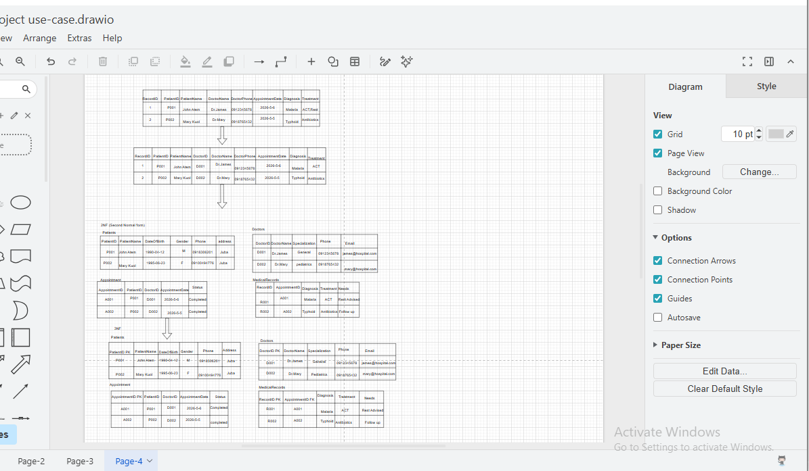

Selected Architectural Pattern
Model-View-Controller (MVC)
The Digital Patient Record Management System will use the Model-View-Controller (MVC) architectural pattern.
Justification
MVC was selected because it separates the application into three independent components:
Model manages the patient database, appointments, medical records, and user information.
View provides the user interface for patients, doctors, healthcare workers, and administrators.
Controller processes user requests, validates data, manages authentication, and communicates between the interface and the database.
Using MVC makes the system easier to develop, maintain, and expand. It also improves code organization, supports future updates, and allows different developers to work on separate components of the system simultaneously. Since the project includes multiple users and several functional modules, MVC provides a suitable architecture for managing these operations efficiently.
GitHub Repository Initialization
The project repository will be created on GitHub to support version control and collaboration throughout the software development process. GitHub will be used to store the project source code, documentation, and design files while keeping track of changes made during development.
Repository Name:

Digital-Patient-Record-Management-System

GitFlow Branching Strategy
The project will follow the GitFlow branching model.
The branches will include:

main – Contains the stable and production-ready version of the project.
develop – Used for integrating completed features before release.
feature/user-authentication – Development of the login and registration module.
feature/patient-management – Development of patient registration and management.
feature/appointments – Development of appointment scheduling.
feature/report-generation – Development of reporting functionalities.
release/v1.0 – Final testing before deployment.
hotfix/security-fix – Used for urgent bug fixes after deployment.
This answer directly matches your concept paper and fulfills all the Week 5 assignment requirements: Use Case Diagram, Sequence Diagram, 3NF Normalization, ERD, MVC justification, GitHub repository initialization, and GitFlow branching strategy.

